**PARCC/MISA Item Set ES - PARCC/MISA - Weathering and Erosion**

**STIMULUS PART ONE:** There is a common aesthetic appeal to construct houses at the tops of hills or seas-side cliffs so that the home’s residents can enjoy the beautiful landscape or seascape views. Many of these residents who live in these locations experience property damage or loss, and some even lose their homes due to a process called hillside erosion. Hillside erosion may also be referred to as mass movement, and it is defined as when agents of erosion cause sediment or material that make up the slope of a hill or cliffto dislodge and transport to a lower elevation.

Scientists have gathered data from two different coastal locations where hillside erosion is taking place. The data includes the number of occurrences from each location and the amount of material lost or eroded for each month of the year.

**Monthly Data - Reporting Numbers of Major Property Loss or Damage due to Hillside Erosion**

|  |  |  |  |  |  |  |  |  |  |  |  |  |
| --- | --- | --- | --- | --- | --- | --- | --- | --- | --- | --- | --- | --- |
|  | **Jan** | **Feb** | **Mar** | **Apr** | **May** | **Jun** | **Jul** | **Aug** | **Sep** | **Oct** | **Nov** | **Dec** |
| **Santa Barbra, CA** | 10 | 8 | 7 | 2 | 1 | 1 | 2 | 1 | 2 | 3 | 5 | 7 |
| **Bar Harbor, ME** | 13 | 10 | 12 | 9 | 7 | 5 | 4 | 4 | 6 | 9 | 14 | 12 |

**Amount of Material/Sediment Lost in Cubic Meters due to Mass Movements**

|  |  |  |  |  |  |  |  |  |  |  |  |  |
| --- | --- | --- | --- | --- | --- | --- | --- | --- | --- | --- | --- | --- |
|  | **Jan** | **Feb** | **Mar** | **Apr** | **May** | **Jun** | **Jul** | **Aug** | **Sep** | **Oct** | **Nov** | **Dec** |
| **Santa Barbra, CA** | 210 | 188 | 160 | 38 | 21 | 18 | 33 | 23 | 34 | 41 | 89 | 122 |
| **Bar Harbor, ME** | 231 | 189 | 200 | 161 | 125 | 98 | 80 | 76 | 108 | 160 | 261 | 208 |

**STIMULUS PART TWO:** Scientists know and understand that different forms of weathering can affect the rate of which erosion takes place. Scientists are looking for a correlation between the rates of hillside erosion and several agents or processes of weathering.

The climate for these two regions are different. Santa Barbra, CA sits along the Pacific coast and has a Mediterranean climate, with warm to hot, dry summers and mild, moderately wet winters. Bar Harbor, ME sits along the Atlantic coast and has a humid continental climate with warm (although generally not hot), humid summers. Winters are cold and snowy throughout the state with temperatures often fluctuating between above and below freezing temperatures.

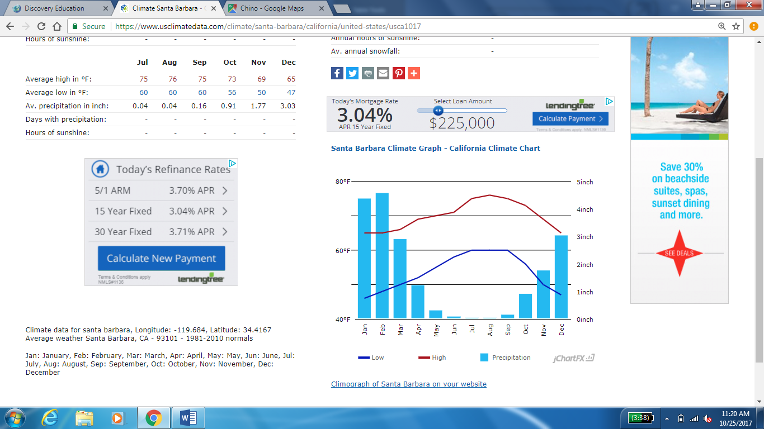

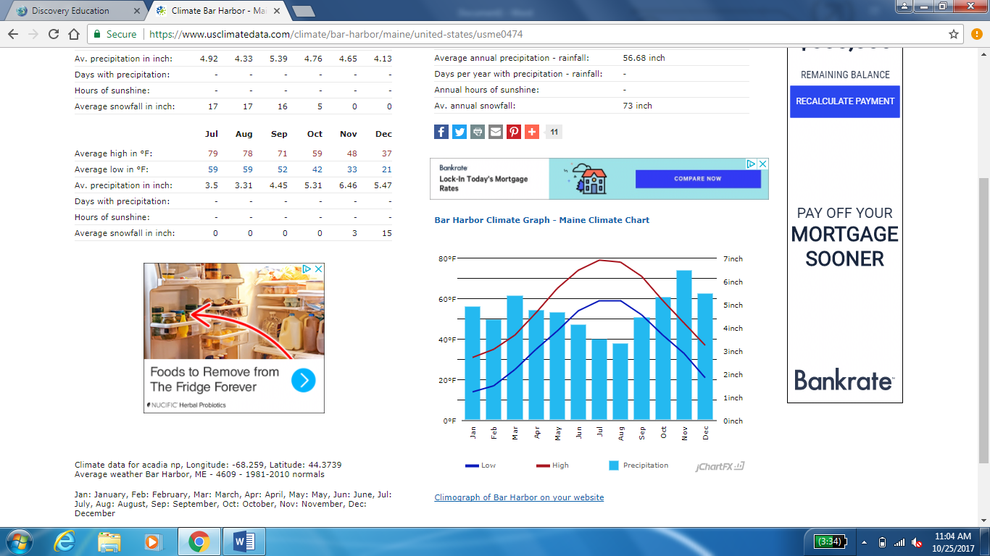

**Constructed Response:** Scientists are making the claim that faster rates of weathering has a direct correlation with the rate of which hillside erosion is taking place in Santa Barbra, CA and Bar Harbor, ME. Use the evidence and data presented in stimuli part one and two to support the claim that the scientists have made.

________________________________________________________________________________________________________________________________________________________________________________________________________________________________________________________________________________________________________________________________________________________________________________________________________________________________________________________________________________________________________________________________________________________________________________________________________________________________________________________________________________________________________________________________________________________________________________________________________________________________________________________________________________________________________________________________________________________________________________________________________________________________________________________________________________________________________________________________________________________________________________________________________________________________________________________________________________________________________________________________________________________________________________________________________________________________________________________________________________________________________________________________________________________________________________________________________________________________________________________________________________________________________________________________________________________________________________________________________________________________________________________________________________________________________________________________________________________________________________________________________________________________________________________________________________________________________________________________________________________________________________________________________________________________________________________________________________________________________________________________________________________________________________________________________________________________________________________________________________________________________________________________________________________________